**AIM:** page replacement algorithm :- FIFO(First in First Out)

**THEORY:**

The simplest page-replacement algorithm is a FIFO algorithm. The first-in, first-out (FIFO) page replacement algorithm is a low-overhead algorithm that requires little bookkeeping on the part of the operating system. The idea is obvious from the name – the operating system keeps track of all the pages in memory in a queue, with the most recent arrival at the back, and the oldest arrival in front. When a page needs to be replaced, the page at the front of the queue (the oldest page) is selected. While FIFO is cheap and intuitive, it performs poorly in practical application. Thus, it is rarely used in its unmodified form. This algorithm experiences Bélády's anomaly.

FIFO page replacement algorithm is used by the VAX/VMS operating system, with some modifications. Partial second chance is provided by skipping a limited number of entries with valid translation table references, and additionally, pages are displaced from process working set to a system wide pool from which they can be recovered if not already re-used.

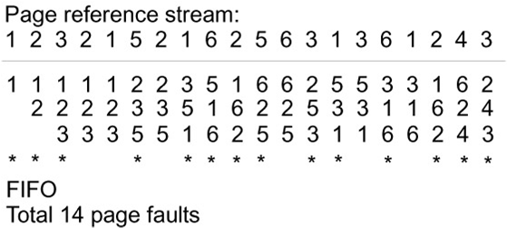

.

**Flowchart:-**

**Conclusion:-**